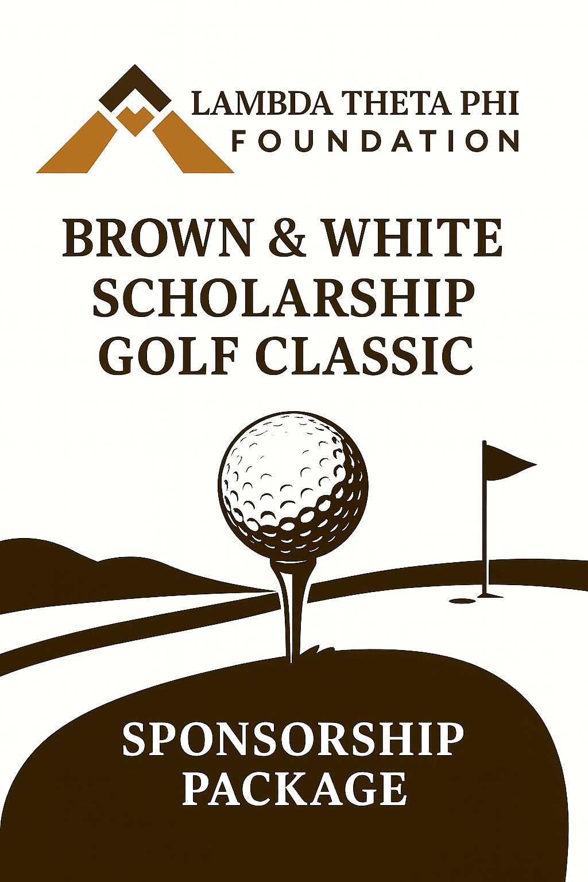

PREPARED FOR:
Potential Corporate & Organizational Sponsors

BENEFITING:
Lambda Theta Phi Foundation, 501c3
www.lambdathetaphifoundation.org

Message from National Chairman

Potential Partner,
Lambda Theta Phi Latin Fraternity, Inc. proudly celebrates 50 years of advancing Latino leadership, education, and community impact nationwide. This historic milestone brings together thousands of alumni and undergraduate members—professionals, entrepreneurs, and decision-makers—who are shaping industries and strengthening communities across the United States.
As part of this golden anniversary, the Lambda Theta Phi Foundation is launching its inaugural Brown & White Scholarship Golf Classic, taking place Friday, July 10, 2026, at the Harry L. Jones Sr Golf Course in Charlotte, North Carolina. This national, alumni-driven event is designed to fund scholarships and leadership development programs that directly support Latino students and emerging leaders.
With a **98.7% member graduation rate—nearly double the national Latino average of 52%—**our Foundation delivers measurable, proven outcomes. This is not a local golf outing; it is a national investment in the future of Latino leadership, powered by a deeply engaged alumni network spanning every major metropolitan area in the country.
By partnering with the Lambda Theta Phi Foundation, your organization aligns with a trusted national institution and gains:
- Tax-Deductible Impact – Sponsorships are tax-deductible to the extent allowed by law, providing a strategic philanthropic investment.
- Meaningful Educational Outcomes – Direct support for scholarships and leadership programs that increase college access, completion, and professional readiness.
- National Brand Visibility – Exposure across event materials, digital platforms, email campaigns, and social media, reaching thousands of loyal alumni and supporters.
- Authentic Community Engagement – A meaningful opportunity to demonstrate a commitment to Latino leadership, education, and long-term opportunity.
- Strategic Networking & Growth – Engagement with national network of college-educated Latino professionals across finance, technology, education, healthcare, government, and nonprofit sectors.
We welcome the opportunity to customize a sponsorship partnership that aligns with your organization’s values and business objectives. I invite you to connect with me directly at President@LambdaThetaPhiFoundation.org to explore how your organization can play a role in this national effort.
Sincerely,
Byron G. Bustos
Chairman, Lambda Theta Phi Foundation

Why Partner with the Lambda Theta Phi Foundation
The Lambda Theta Phi Foundation exists to advance the mission of the first nationally recognized Latino fraternity in the United States, Lambda Theta Phi, Latin Fraternity, Inc. an organization with more than 184 chapters nationwide.
A partnership with the Foundation goes beyond visibility. It provides authentic access to a nationally connected, highly influential alumni network of college-educated Latino professionals. Our members serve as educators, attorneys, technologists, entrepreneurs, healthcare professionals, public servants, and military leaders—many in senior and decision-making roles.
Your support connects your organization to a community that is both historically underserved by traditional corporate outreach and exceptionally powerful in its collective influence. Lambda Theta Phi alumni demonstrate strong brand loyalty and actively support organizations that invest authentically in education, leadership, and opportunity.
Our impact is measurable and scalable. Through scholarships and leadership development, the Foundation sustains a 98.7% graduation rate, creating a proven national pipeline from higher education to professional and civic leadership.
This is not transactional sponsorship; it is a strategic partnership rooted in:
- Empowerment – Expanding access and opportunity for Latino students and emerging leaders.
- Education – Supporting college completion and long-term professional success.
- Leadership – Strengthening a national pipeline of Latino leaders across sectors.
- Community Impact – Aligning with a trusted institution committed to sustained, measurable change.

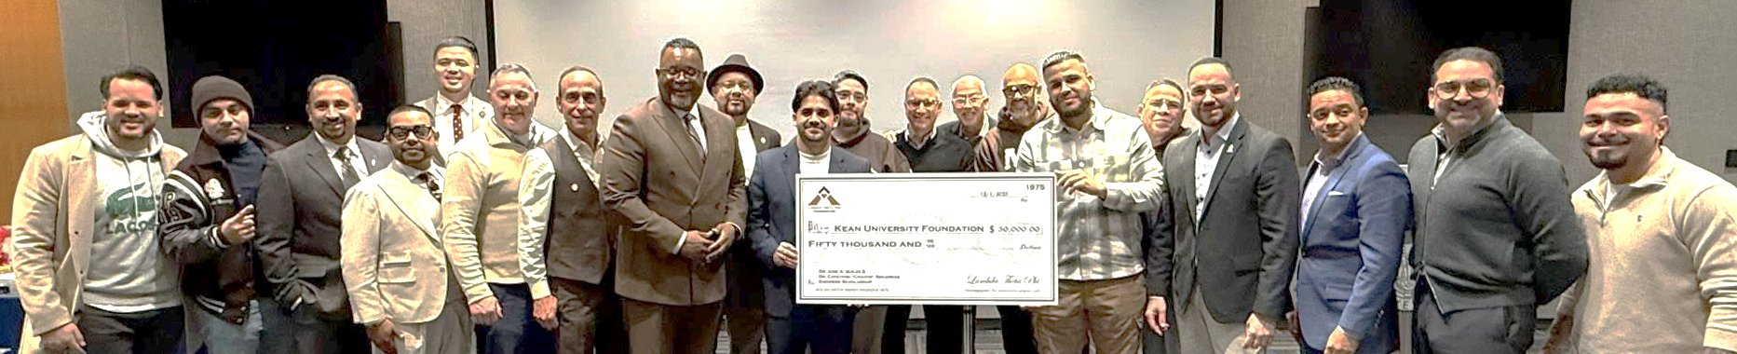
December 2025 - On the 50th Anniversary of Lambda Theta Phi, Latin Fraternity, Inc. presented a $50,000 check to the Kean University Foundation in Union, New Jersey.

THE LAMBDA LEGACY

- Over 5,000 Alumni and Undergraduate Members Nationwide
- Over 184 Entities Nationwide
- Average Member Age: 33
- 15,000+ social media followers across platforms
- Expected Attendance at Convention: 500
- Membership graduation rate: 98.7%
(U.S. Latino national average: 52%)
- Members with post-graduate degrees: 11.5%
(U.S. national average: 4%)

Past & Current Partnerships Include:

- American Heart Association
- Congressional Hispanic Caucus Institute
- Walmart
- Southwest Airlines
- Big Brothers Big Sisters
- Spanish Broadcasting System
- Mega TV
- La Musica
- Live Creations

Why Latinos Impact Matters:
- Latinos represent 20% of the U.S. population and generate $4.1 trillion in GDP
- 70% of U.S. Latinos are under age 35
- By 2030, Latinos will comprise 26% of all Americans 18
- Latinos under 35 spend $400+ billion annually

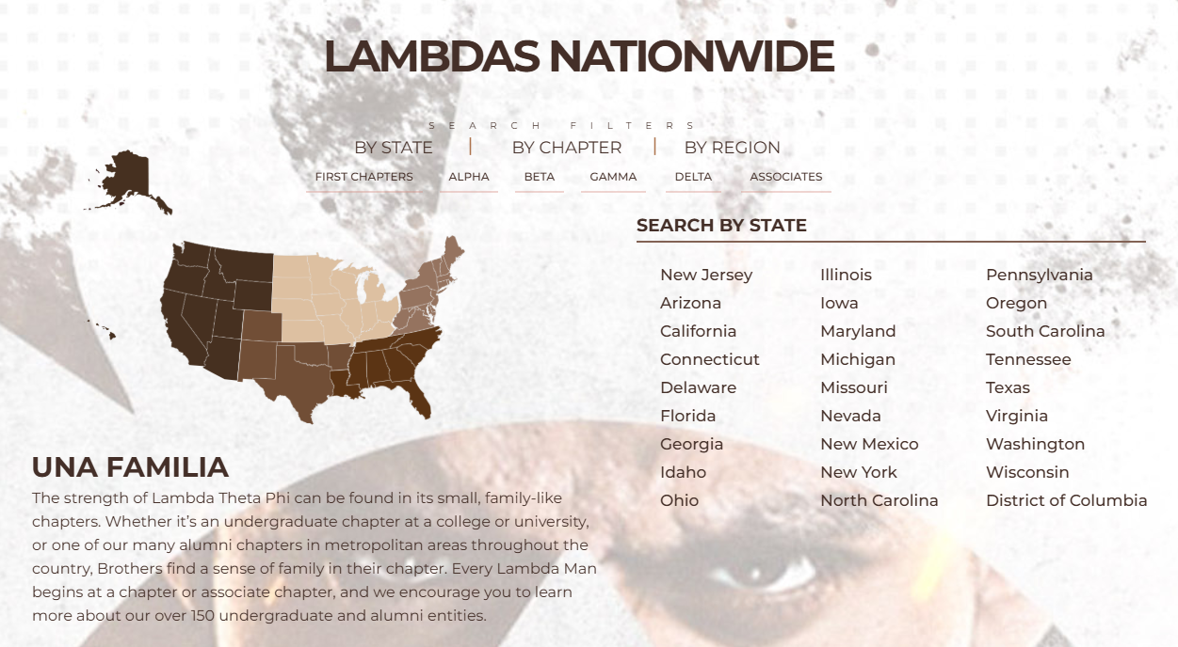

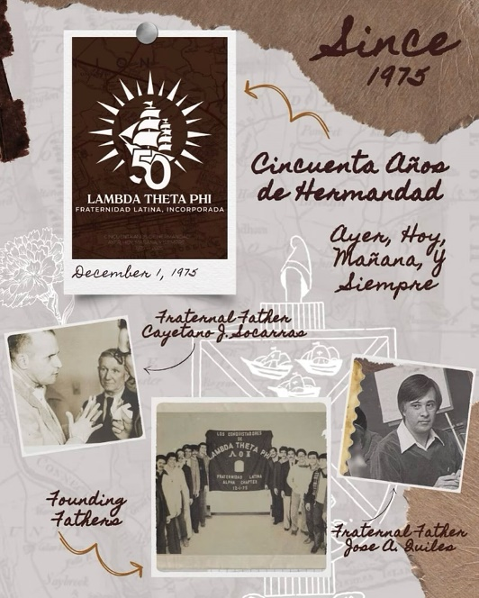

SPONSORSHIP LEVELS

Gold Sponsor - $7,5000
Premium, exclusive visibility, and engagement opportunities.
- Everything included in the Silver Sponsor package plus...
- Creation of a $5,000 Book Scholarship named after the Gold Sponsor to be administered by the Foundation for annual recognition.
- Opportunity to hold a webinar or professional development session for members
- Branded golf towels provided to all players
- Opportunity to address participants during the tournament

Silver Sponsor - $5,000
Strong brand visibility with direct engagement opportunities.
- Everything included in the Bronze Sponsor package plus...
- Logo placement with link on Foundation website for one year
- Recognition across Foundation social media platforms
- Logo and feature content in quarterly Foundation newsletters for one year

Bronze Sponsor - $2,500
Meaningful exposure and event participation.
- Sponsor recognition at the Brown & White Scholarship Golf Classic
- On-site presence to interact with golfers
- Option to include branded items in player swag bags
- Four (4) tournament registrations (including lunch & swag) plus four (4) social guests passes

Hole Sponsorship - $500
Targeted, on-course brand engagement.
- Branded signate at sponsored hole
- Opportunity to interact directly with golfers at the hole and lunch.
- Two (2) lunch tickets included

Please use our Zeffy account to purchase:

Sponsorship Package: SPONSORS

Golf Tournament Tickets: TICKETS

Mail Checks to: Lambda Theta Phi Foundation
9874 Notting Hill Drive
Frederick, MD 21704

Lambda Theta Phi Foundation, 501c3 www.lambdathetaphifoundation.org

